**UNIVERSITY OF KABIANGA**

**DEPARTMENT OF MATHEMATICS AND COMPUTER SCIENCE**

**PROJECT CONCEPT PRESENTATION**

**COURSE CODE: COM423**

**COURSE NAME: COMPUTER SCINCE PROJECT II**

**GROUP NO.: COM Y4 GROUP5**

**PROJECT PROPOSED TITLE:**

INDUSTRIAL ATTACHMENT PLACEMENT MANAGEMENT SYSTEM

**BRIEF DESCRIPTION OF PROJECT (one paragraph)**

Many tertiary students apply for industrial attachment themselves to gain relevant experience as well as to get to determine if they have genuine interest in a certain career field. Getting a relevant Place Of Attachment is a tideos process and many a times make students settled in irrelevant fields which does not satisfy them with effecient Industrial attachment experience. Industrial Attachment Placement Management system for coordinating attachment placement with the goal of facilitating communication between various organizations and the university will come in handy to smoothen the process associated with placement of students to specific industrial fields. A student can access the system and the details of various organizations having industrial attachment programs, the student can choose the organizations they wish to go for the attachment and apply. The students gets notified through emails when they secure an opportunity to go for attachment in any of the applied organisations. Coordinators as well will get notified of succeful placement of students and will be able to monitor the progress of their students through weekly updates of students' progress.

**PROBLEM TO BE SOLVED (one sentence)**

Industrial Attachment Placement Management System will provide an easy and time-saving process of attachment application and placement because some students apply for attachment and the feedback from the organization takes time.

**PROPOSEED PROJECT USER INTERFACE (Sketch/Draw/Paste)**

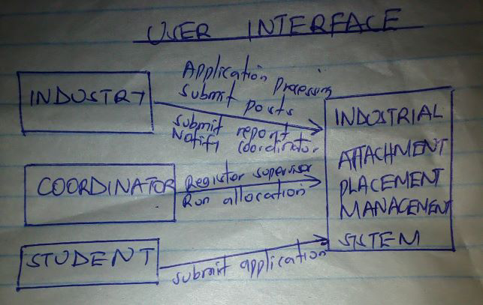

|  | **PRESENTERS** | |  |  |
| --- | --- | --- | --- | --- |
| **S/N** | **REG. NO.** | **NAMES** | | **SIGN** |
| **1** | COM/M/0052/2018 | SYLVESTER KIPKEMOI | |  |
| **2** | COM/M/0033/2018 | LAVENA OKILE | |  |
| **3** | COM/M/0010/2018 | EDWIN MOMANYI | |  |
| **4** | COM/M/0007/2018 | KUBAI H. MWENDA | |  |
| **5** | COM/M/0049/2018 | EDWIN WANGO | |  |
| **6** | COM/M/0038/2018 | KEITH WASWA | |  |
| **7** | COM/M/0057/2018 | FELIX CHARLES OCHIENG | |  |
| **8** | COM/M/0047/2018 | GLORIA AWUOR | |  |
| **9** | COM/M/0045/2018 | WILLIS OTIENO | |  |

**SUPERVISOR_______________________**

**SIGN:_______________________________**

**DATE_______________________________**